**BLOCK DIAGRAM**

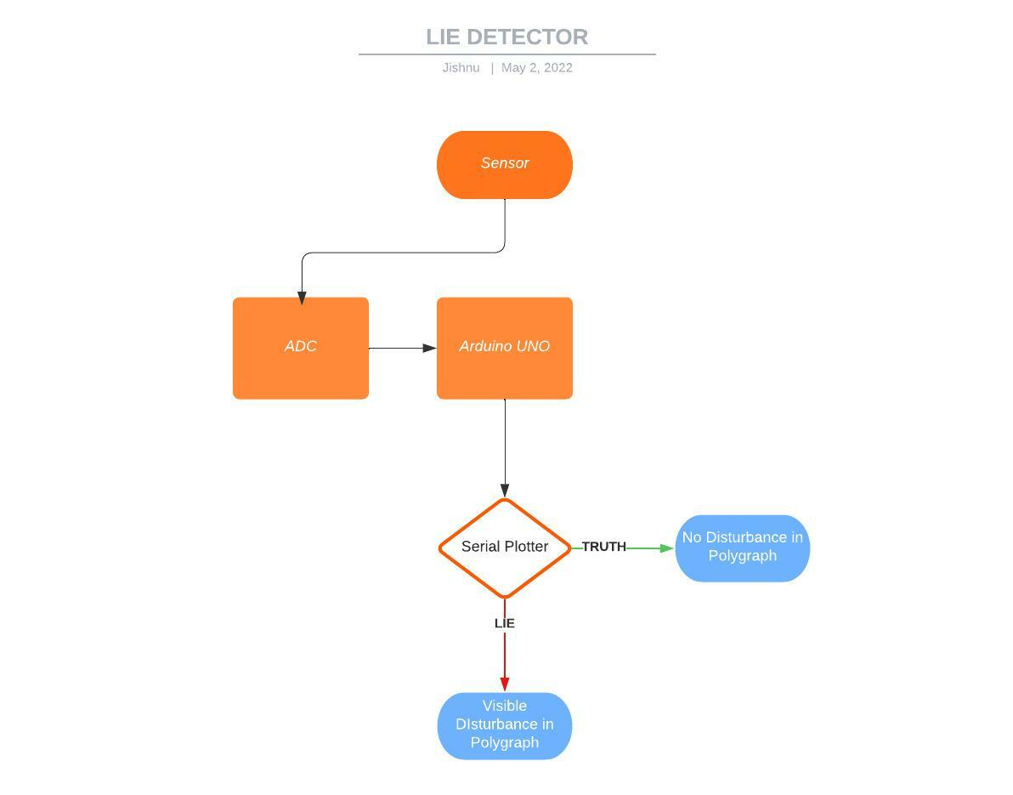

**CIRCUIT DIAGRAM & DESCRIPTION:-**

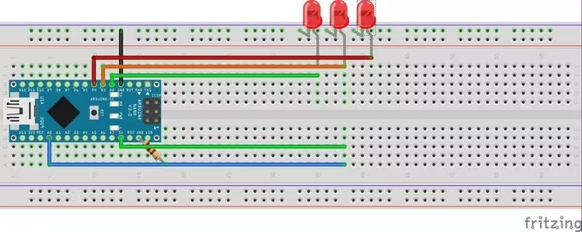

Circuit diagram of Lie Detector.

**STEP 1:-**

HOW IT WORKS Our skin is amazing! It provides a medium for us to experience the sense of touch, it keeps infections out and keeps innards in but you didn't know that our skin changes conductivity depending on many different things one being our mood! It called Electro dermal activity (EDA).The basics are that our skin changes its conductivity depending on how we feel. We start by connect our Arduino to the subject and then connect the Arduino to a computer with the software. We have to start by asking the subject some easy questions we know they will answer truthfully like "what is your name" and "where do you live" to get a baseline and from there we can start asking questions that they may lie about, if they do they would probably feel nervous and then we can read the change in the baseline that be established earlier if they lie.

**STEP 2:-**

COMPONENTS WE HAVE USED We are going to need a microcontroller to control the two LEDs and send the computer the data. In order for the computer receive the data from the microcontroller to have a serial communication chip (USB communication chip).Hence we required

1. Arduino UNO

2. LEDs

3. Resistors(10K)

4. Sensors

**STEP 3:-** CONNECTIONS Connect the resistors with their required position and connect with Arduino uno . Finally, we need to keep the sensor wires on our fingers.

**STEP 4:-** SOFTWARE INSTALLATION and CODE GENERATION The new update brings a new way to see the data being received from the Arduino,it can now be displayed in a real time graph which will help us identify when the data changes its pattern(when someone lies). The code for the microcontroller downloads the attached file, we have to open it and upload it on board.